https://leetcode.com/problems/reverse-integer/submissions/2191398128/

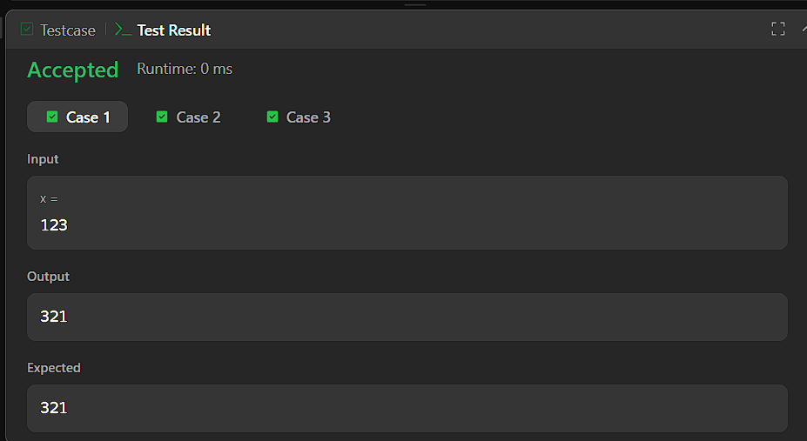

CODE:

int reverse(int x){
int rev = 0;

while (x != 0) {
int d = x % 10;
x /= 10;

if (rev > INT_MAX / 10 || (rev == INT_MAX / 10 && d > 7)) {
return 0;
}
if (rev < INT_MIN / 10 || (rev == INT_MIN / 10 && d < -8)) {
return 0;
}

rev = rev * 10 + d;
}

return rev;
}

